Table S1. Summary of evidence for Fall armyworm developmental and population responses to the environment, and impacts on maize at different life stages. All papers studied Fall armyworm in or from locations where populations are established year round (i.e. are not migratory). Papers were sourced through searching Web of Science, and bibliographies of papers. Papers in English, Spanish, Portuguese were studied, though a few potentially relevant references for which we could not source PDFs were excluded. Findings where effects were not significant are included, but effects only reported if a statistical test was done. Information in grey shaded cells were included in life-cycle diagram, Fig. 1. “RH” is Relative Humidity, “N” is sample size. Unless otherwise noted, moths were reared on fresh corn or an artificial diet. In some cases the statistical approach might be criticised by modern standards. Measurements are grouped according to the environment or crop variable studied, and then ordered according to life-cycle stage from egg to adulthood.
Environment or crop variable studied | Fall armyworm life-stage and outcome studied | Interpretation of effect found | Study type, evidence for and magnitude of effect | Reference
Air temperature (21°C, 25°C, 30°C) | Egg viability | No effect of air temperature | Mean egg viability 92%. N=148 | [1]
Air temperature (18-32°C) | Egg viability | Hump-shaped relationship with temperature, with survival greatest at 25°C. | Lab study. Under constant temperatures mean egg survival from different biotypes and populations was 67.7-72.7% at 18°C, 95.7-98.3% at 25°C, 73.1-79.1% at 32°C. Survival at 25°C significantly higher than at the other temperatures using Tukey’s HSD test, p<0.05. N=180. | [2]
Air temperature (18-32°C) | Egg duration | Negative relationship with temperature, with development fastest at 32°C. | Lab study. Under constant temperatures mean egg duration from different biotypes and populations was 4.7-4.8 days at 18°C, 2.4-2.6 days at 25°C, and 2 days at 32°C. For all but one population differences at all three temperatures were significantly different using Tukey’s HSD test, p<0.05. N=180. | [2]
Air temperature (lower) | Minimum temperature threshold, and egg, larval, and pupal development times | 13.8°C is the minimum threshold for development. The number of air degree days above 13.8 needed to complete all immature life stages is 346-334 days on average (males and females respectively). | Lab studies of minimum temperature threshold for development of eggs, larvae, male and female pupae: 13.4°C, 13.9°C, 13.8°C, 12.9°C respectively. 13.8°C when both sexes and larval and pupal stages were combined. N not given.  Mean air degree days (±s.d.) above 13.8°C for completing each life-history stage were:  Egg 34.1 ±2.2  Larvae 174.2 ±9.6  Pupa males 138.7 ±8.7, females 123.7 ±10.3  Larvae + pupa males 312.1 ±15.5, females 299.4 ±15.0 | [3]
Air temperature (lower) | Minimum temperature threshold for egg hatching | 9.7°C is the minimum threshold for egg hatching | Lab study of minimum temperature threshold for egg hatching, 8-40°C. Second degree polynomial curve fitted by least squares regression (R²=0.88, N=15) | [4]
Air temperature (lower) | Minimum temperature threshold for larval survival (all instars) | 7.4°C is the minimum threshold for larval survival. | Lab study of minimum temperature threshold for larval survival, 8-40°C, on maize seedlings. Second degree polynomial curve fitted by least squares regression (R²=0.94, N=18) | [4]
Air temperature (lower) | Minimum temperature threshold for pupal survival | 9.4°C is the minimum threshold for pupal survival. | Lab study of minimum temperature threshold for pupal survival, 8-40°C. Second degree polynomial curve fitted by least squares regression (R²=0.88, N=18) | [4]
Air temperature (lower) | Minimum temperature threshold for entire life-cycle | 8.7°C is the minimum threshold for egg hatching | Lab study of minimum temperature threshold for life-cycle, 8-40°C. Second degree polynomial curve fitted by least squares regression (R²=0.88, N=51) | [4]
Air temperature (optimum) | Optimum temperature threshold for egg hatching | 24.6°C is the optimum temperature for egg hatching | Lab study of optimum temperature threshold for egg hatching, 8-40°C. Second degree polynomial curve fitted by least squares regression (R²=0.88, N=15) | [4]
Air temperature (optimum) | Optimum temperature threshold for larval survival (all instars) | 25.9°C is the optimum temperature for larval survival. | Lab study of optimum temperature threshold for larval surviva, 8-40°C, l on maize seedlings. Second degree polynomial curve fitted by least squares regression (R²=0.94, N=18) | [4]
Air temperature (optimum) | Optimum temperature threshold for pupal survival | 24.6°C is the optimum temperature for pupal survival. | Lab study of optimum temperature threshold for pupal survival, 8-40°C. Second degree polynomial curve fitted by least squares regression (R²=0.88, N=18) | [4]
Air temperature | Basal temperature for whole life-cycle duration (egg-adult) | Basal temperature possibly higher for corn biotype than rice biotype. | Basal temperature 10.6°C and 10.9°C for two populations of the corn biotype, and 9.5°C and 9.6°C for two populations of the rice biotype. No significance test done. | [2]
Air temperature (21°C, 25°C and 30°C) | Larval developmental time (from egg hatch to eclosion) | Developmental time decreased as temperature increased. | Lab study. Number of days for development was significantly different at 21°C (mean 34.1-40.8 days depending on maize stage consumed), 25°C (mean 27.5-33 days depending on maize stage consumed), and 30°C (mean 18.8-21 days depending on maize stage consumed). Duncan’s New Multiple Range Tests, p ≤0.05, N=136. | [1]
Air temperature (28.9-33.5°C) | Larval developmental time (from 4th instar to pupation) | Developmental time (on soy-bean diet) decreased with temperature. | Lab study. Under constant temperatures, mean developmental time was 11.6 days at 28.9°C, and 9.1 days at 33.5°C. GLMM, p=0.0009, N=240. | [5]
Air temperature (constant 25°C and 30°C, fluctuating 31/21°C) | Larval developmental time (from neonate to pupation) | Developmental time decreased with warmer daytime temperatures. FAW larvae at 30°C developed approx. 1.6- and 1.3-fold faster than larvae that fed at 25 and 31/20°C, respectively. Mean developmental time of FAW larvae at 31/20°C was approx. 1.2-fold that of larvae at 25°C. | Lab study. Relative humidity 70±5%. Photoperiod 14:10. Mean developmental time 25.6 days at constant 25°C, 15.6 days at constant 30°C, 19.1 days at fluctuating 31/20°C. Duncan’s multiple range test, p<0.05, N=300 | [6]
Air temperature (25°C) | Larval developmental time (from neonate larvae to eclosion) | 13.04-16.17 days (on soy-bean diet) | Lab study. Under constant 25°C temperature mean neonate-eclosion duration from different populations was 13.04-16.17 days. N=250. | [7]
Air temperature (18-32°C) | Larval developmental time (from neonate to eclosion) | Negative or negative asymptotic relationship with temperature, with development fastest at 32°C. | Lab study. Under constant temperatures mean larval duration from different biotypes and populations was 33.3-41.9 days at 18°C, 13.2-16.5 days at 25°C, and 11.1-12.9 days at 32°C. Differences between 18 and 25°C were significant for all four populations, differences between 25 and 32°C were significant for two populations using Tukey’s HSD test, p<0.05. N=150. | [2]
Air temperature (lower) | Larval survival (from neonate to eclosion) | The minimum temperature threshold for development is lower for younger maize leaves | Temperature threshold for development was 9.2°C, 12.6°C, 14.0°C on leaves from maize stages 1-2 (early vegetative), 3-4 (late vegetative), 5-6 (reproductive) respectively (estimated by linear regression, N=136). | [1]
Air temperature (18-32°C) | Larval survival (from neonate to eclosion) | Hump-shaped relationship with temperature, with survival greatest at 25°C. | Lab study. Under constant temperatures mean larval survival from different biotypes and populations was 62.0-81.3% at 18°C, 90.7-96.7% at 25°C, 55.3-77.3% at 32°C. Survival at 25°C significantly higher than at the other temperatures using Tukey’s HSD test, p<0.05. Populations from both biotypes sampled adjacent to a river had significantly lower survival at 18°C than other populations. N=150. | [2]
Air temperature (constant 25°C and 30°C, and day/night fluctuating 31/21°C) | Larval fresh weight nine days after hatching | Weight increased with warmer daytime temperatures. FAW larvae that fed at 30°C were approx. 3- and 1.5-fold larger than larvae that fed at 25 and 31/20°C, respectively. Mean weight of FAW larvae fed at 31/20°C was approx. 2-fold that of larvae fed at 25°C. | Lab study. Relative humidity 70±5%. Photoperiod 14:10. Mean weight 116.7g at constant 25°C, 402.8g at constant 30°C, 276.9g at fluctuating 31/20°C. Duncan’s multiple range test, p<0.05, N=300. | [6]
Air temperature (18-32°C) | Pre-pupal survival until eclosion | Survival drops at 32°C | Lab study. Under constant temperatures mean pre-pupal survival from different biotypes and populations was 92.6-98.9 % at 18°C, 95.0-97.9% at 25°C, 63.8-75.0% at 32°C. Survival at 32°C was significantly lower than at the other temperatures using Tukey’s HSD test, p<0.05. N<150. | [2]
Air temperature (18-32°C) | Pupal development rate until eclosion | Negative relationship with temperature, with development fastest at 32°C | Lab study. Under constant temperatures mean pupal duration from different biotypes and populations was 20.1-30.4 days at 18°C, 8.8-10.6 days at 25°C, and 6.6-7.1 days at 32°C. Differences at all three temperatures were significantly different using Tukey’s HSD test, p<0.05. | [2]
Air temperature (18-32°C) | Pre-pupal development rate until eclosion | Negative relationship with temperature, with development fastest at 32°C. | Lab study. Under constant temperatures mean pre-pupal duration from different biotypes and populations was 3.6-4.8 days at 18°C, 1.8-2.4 days at 25°C, and 1.1-1.4 days at 32°C. Differences between 18 and 25°C were significant for all four populations, differences between 25 and 32°C were significant for two populations using Tukey’s HSD test, p<0.05. N<150. | [2]
Air temperature (10-40°C) | Pupal development rate until eclosion | Fastest at 30-35°C, and faster for females than males. | Lab study. At 15°C development rate is 39 days for males and 34.4 days for females. At 35°C development rate is 6 days for males and 5.2 days for females. Females developed significantly faster than males (t-test, p=0.0001, N=30). | [8]
Air temperature (lower) | Minimum temperature threshold for pupal eclosion | Air degree days above 10°C for pupal eclosion is 156.7. | Lab study. Mean number of air degree days above 10°C required for pupa to emerge was 156.7, N=160. | [9]
Air temperature (lower) | Minimum temperature threshold for pupal eclosion | Air degree days above 10°C for pupal eclosion is 198. | Field study in Peninsular Florida, USA. Mean number of air degree days above 10°C required for pupa to emerge was 198 (range not given, N=160) | [9]
Air temperature (lower) | Minimum temperature threshold for pupal eclosion | Air degree days above 10°C for pupal eclosion is 169.3. | [as cited in 9] | [10]
Air temperature (lower) | Minimum temperature threshold for pupal eclosion | Air degree days above 10°C for pupal eclosion is 159.7. | [as cited in 9] | [11]
Air temperature (lower) | Minimum temperature threshold for pupal survival to eclosion | 10°C is lower threshold for pupal development | Field study in Peninsular Florida, USA. Pupae held at 10°C lived for about 50 days but did not eclose. No moths were recovered during months with more than one day below this developmental threshold. N=160 | [9]
Air and soil temperature, rainfall | Pupal survival to eclosion | Survival greatest in sites with the warmest mean soil temperature, warmest lower soil and air temperatures, and in sites with higher rainfall. | Field study in Peninsular Florida, USA. In descending order of importance, mean soil temperature, minimal soil, extreme low soil, extreme low air temperatures, and rainfall, all had a significant effect on pupal survival till eclosion, R²= 94-95%, p-value not given, N=160. | [9]
Air temperature (10-40°C) | Pupal survival to eclosion | Hump-shaped relationship with temperature, with eclosion highest between 20-35°C. No survival outside 15-35°C. | Lab study. No eclosion below 15°C, 65-85% eclosion at 15°C, 90% eclosion at 20-35°C for males and 70-90% for females, no eclosion above 40°C.N=180. | [8]
Air temperature (18-32°C) | Pupal survival until eclosion | Suggestion of hump-shaped relationship with temperature, with survival greatest at 25°C. | Lab study. Under constant temperatures mean pupal survival from different biotypes and populations was 81.1-84.3% at 18°C, 92.5-96.5% at 25°C, 71.6-91.9% at 32°C. Survival at 25°C significantly higher than at the other temperatures for one population, using Tukey’s HSD test, p<0.05. N<150. | [2]
Air temperature (25°C) | Weight at pupation | 0.156-0.215g (on soy-bean diet) | Lab study. Under constant 25°C temperature mean pupal weight from different populations was 0.156-0.215g. N=250. | [7]
Air temperature (28.9-33.5°C) | Weight at pupation | No effect of temperature (on soy-bean diet). | Lab study. Under constant temperatures, mean pupal weight was 0.186g at 28.9°C, and 0.188g at 33.5°C. GLMM, p=0.7714, N=240. | [5]
Air temperature (21°C, 25°C, 30°C) | Pre-ovipositional period | No effect of air temperature | Mean pre-ovipositional period 4.5 days. N=136 | [1]
Air temperature (upper, 21°C, 25°C and 30°C) | Fecundity | Fecundity higher at 21 and 25°C than 30°C | Lab study. Number of eggs laid per female was significantly lower at 30°C (on average 890-1337 eggs depending on maize stage consumed) than at 21°C or 25°C (on average 1510-2080 eggs depending on maize stage consumed). Duncan’s New Multiple Range Test, p ≤0.05 for 30°C vs 21°C and 25°C, N=75. | [1]
Air temperature (21°C, 25°C and 30°C) | Fecundity | Daily temperature fluctuations had no effect | Lab study. Varying temperature sinusoidally between 20°C and 30°C with a mean of 25°C had no effect relative to a constant temperature of 25°C. Range of average fecundity between treatments is 1375-1921 eggs per female. N not given. | [1]
Air temperature (21°C, 25°C and 30°C) | Adult longevity | Adult longevity longer at 21 and 25°C than 30°C | Lab study. Longevity lower at 30°C (on average 11.90-12.9 depending on maize stage consumed) than 21 and 25°C (on average 14.5-20.5 depending on maize stage consumed). Duncan’s New Multiple Range Test, p ≤0.05 for 30°C vs 21°C and 25°C, N=75. | [1]
Air temperature (21°C, 25°C and 30°C) | Adult female longevity | Daily temperature fluctuations had no effect | Lab study. Varying temperature sinusoidally between 20°C and 30°C with a mean of 25°C had no effect relative to a constant temperature of 25°C. Range of average longevity between treatments is 14.8-19.1. N not given. | [1]
Air temperature (upper) | Maximum temperature threshold for egg hatching | 39.5°C is the upper threshold for egg hatching | Lab study of upper temperature threshold for egg hatching, 8-40°C. Second degree polynomial curve fitted by least squares regression (R²=0.88, N=15) | [4]
Air temperature (upper) | Maximum temperature threshold for larval survival (all instars) | 39.2°C is the upper threshold for larval survival. | Lab study of upper temperature threshold for larval survival on maize seedlings, 8-40°C. Second degree polynomial curve fitted by least squares regression (R²=0.94, N=18) | [4]
Air temperature (upper) | Maximum temperature threshold for pupal survival | 39.8°C is the upper threshold for pupal survival. | Lab study of upper temperature threshold for pupal survival, 8-40°C. Second degree polynomial curve fitted by least squares regression (R²=0.88, N=18) | [4]
Air temperature (10-40°C) | Adult moth deformity | High deformity outside 20-30°C. | Lab study. Temperature had a significant effect on deformity, ~55-65% deformity at 15°C (t-test, p=0.0072, N=30). Deformity 58% males and 39% females deformed at 35°C. Deformity ≤10% between 15°C and 35°C. N<180. | [8]
Air temperature (10-40°C) | Adult moth survival | Low temperatures decrease survival. | At 15°C 31% males and 18% females died within 24 hours of eclosion. N<180. No statistical test. | [8]
Air temperature (18-32°C) | Whole life-cycle duration (egg-adult) | Negative relationship with temperature, with development fastest at 32°C | Lab study. Under constant temperatures mean egg-adult duration from different biotypes and populations was 61.3-77.3 days at 18°C, 26.2-32.5 days at 25°C, and 21.0-22.9 days at 32°C. Differences at all three temperatures were significantly different using Tukey’s HSD test, p<0.05. N<150. | [2]
Air temperature (18-32°C) | Whole life-cycle survival (egg-adult) | Hump-shaped relationship with temperature, with survival greatest at 25°C. | Lab study. Under constant temperatures mean egg-adult survival from different biotypes and populations was 34.6-49.4% at 18°C, 79.1-89.7% at 25°C, 24.3-35.8% at 32°C. Survival at 25°C significantly higher than at the other temperatures using Tukey’s HSD test, p<0.05. Results were similar for all populations and biotypes. N<150. | [2]
Air temperature (28.9-33.5°C) | Feeding rate (soy-bean leaf) | Feeding rate increased with temperature. | Lab study. Under constant temperatures, mean feeding rate was 0.37cm/hour at 28.9°C, and 0.53cm/hour at 33.5°C. GLM p=0.0134. N=37 | [5]
Air temperature (constant 25°C and 30°C, fluctuating 31/21°C) | Feeding rate (maize leaf) | Leaf area consumed during first nine days after hatching increased with warmer daytime temperatures. At 30°C, FAW larvae ate approx. 5- and 2-fold more than larvae that fed at 25 and 31/20°C, respectively. Mean weight of FAW larvae fed at 31/20°C was approx. 2.5-fold that of larvae fed at 25°C. | Lab study. Relative humidity 70±5%. Photoperiod 14:10. Mean leaf area consumed 14.9cm² at constant 25°C, 78.71 cm² at constant 30°C, 38.95 cm² at fluctuating 31/20°C. Duncan’s multiple range test, p<0.05, N=300. | [6]
Air temperature | Flight activity | Trap captures were positively correlated with temperature. | Field study with trap data recorded from five sites, on 103 dates over two years, Chiapas, Mexico. N=6770. Spearman’s r=0.32, p=0.016. | [12]
Air temperature fluctuations between 20°C and 30°C | Larval developmental time (from egg hatch to eclosion) | Daily temperature fluctuations decreased developmental time relative to a constant, median temperature | Lab study. Varying temperature sinusoidally between 20°C and 30°C with a mean of 25°C, decreased development by approx. 2 days relative to a constant temperature of 25°C. Duncan’s new multiple range test, p≤0.05, N=65. | [1]
Air temperature, fluctuation between weeks | Larval abundance on maize plants | When soil moisture high, larval abundance is higher following warm spells, but trend is reversed and less pronounced in dry sites. | Field study in northwestern Argentina. At a site that is usually moist, abundance = -1.34 + 1.29*log sum of mean high temperatures one and two weeks previously – 0.29 log mean rainfall one and two weeks previously (N=30, p<0.001, R2=0.99).  At a site that was drier, abundance = 3.89 -0.18*log mean high temperature during sampling week + 0.5 log mean rainfall during sampling week (N=30, p<0.01, R2=0.219).  Temperature range not reported, but sites are in a dry, hot, subtropical zone. | [13]
Air temperature fluctuations | Pupal development rate | At moderate temperatures, fluctuations increases developmental rate. | Lab study. In fluctuating temperature regimes averaging 15°C, 20°C, 25°C, development is faster than at the constant average temperature. The opposite is true at 30°C. N<120. Statistical test used unclear. | [8]
Air temperature fluctuations | Pupal survival to eclosion | No effect of temperature fluctuations. | Lab study. In fluctuating temperature regimes averaging 15°C, 20°C, 25°C there was no difference in eclosion rates relative to the constant average temperature. N=120. | [8]
Air temperature fluctuations | Adult moth deformity | When mean temperature is 15°C, deformity is less frequent under fluctuating temperatures than steady temperatures. | Lab study. In a fluctuating temperature regimes averaging 15°C, deformity was ~half as frequent as at constant temperature. N<60. Statistical test used unclear. | [8]
Soil temperature (lower) | Minimum temperature threshold for pupal eclosion | Soil degree days above 10°C for pupal eclosion is 235. | Field study in Peninsular Florida, USA. Mean number of soil degree days above 10°C required for pupa to emerge was 235 (range 170-325 across four sites, N=160). | [9]
Soil moisture | Larval abundance on maize plants | Soil moisture increases larval abundance in a dry site, with a 1-2 week time lag (possibly by increasing pupal survival), but decreases abundance in a moist site (possibly by increasing larval mortality). Soil moisture modifies relationship between temperature and abundance. | Field study in northwestern Argentina. Moisture levels not reported. At a site that is usually moist, abundance = -1.34 + 1.29*log sum of mean high temperatures one and two weeks previously – 0.29 log mean rainfall one and two weeks previously (N=30, p<0.001, R2=0.99).  At a site that was drier, abundance = 3.89 -0.18*log mean high temperature during sampling week + 0.5 log mean rainfall during sampling week (N=30, p<0.01, R2=0.219). | [13]
Precipitation (22-667mm per week) | Larval abundance (all instars) | Abundance highest during rainy season, lowest during dry season. Larval abundance at any given time is affected by rainfall three weeks earlier. This may be because growth of pasture grass is stimulated by rainfall, making the grass more attractive to ovipositing moths, and resulting in higher abundance after 3-4 week development time. | Field study on pasture land in French Guiana over 75 weeks, capturing 4481 males in pheromone traps. Correlation between weekly rainfall and larval abundance 3 and 4 weeks later (p<0.05 and p<0.01 respectively). In the 15 driest weeks (<25mm) mean larval abundance (number per 100 sweep net samples) was 3.9 (±15.4) compared with 29.7 (±80.6) in rest of year (wet period). | [14]
Precipitation | Larval damage to maize (instars 1 and 2) | Heavy rainfall reduces damage to maize plants by knocking larvae off plant and drowning them. Rainfall fills whorl with water, in which larvae float, until overflows. Wind gusts during rainfall can help this process. | Field study of artificial infestation of sheltered and unsheltered plants 8 and 18 days after plant emergence. For younger plants, number of injured whorls in unsheltered plants was 36% lower than in sheltered treatments. Injury per injured whorl was also lower. For older plants, the number of injured whorls in unsheltered plants was 20% lower than in sheltered treatments (when a watering can was used instead of rainfall, the latter is usually accompanied by wind gusts). Injury per injured whorl was also lower. The differences are reported as significant, but the test was not reported. N was unclear. | [15]
Precipitation | Larval infestation of maize (instars 1 and 2) | Infestation highest in maize deprived of irrigation for longest. Paper suggests this may be because reduced growth of poorly-irrigated plants makes whorl injury more visible (though there is no evidence for reduced growth), because moisture stress favours insect development, because irrigation drowns larvae, or because water stress drives larvae to attack multiple whorls (no evidence for this). | Field study of artificial infestation of maize plants with different irrigation regimes. During the first 21 days of plant growth, the percentage of injured whorls was 10-25% higher for plants irrigated every 14 days than plants irrigated every 7 days (p<0.05). N was unclear. | [15]
Humidity (20-100% RH) | Pupal development rate until eclosion | Relative humidity had no significant effects on pupal development rate | Lab study. N=120. | [8]
Humidity (20-100% RH) | Pupal developmental rate until eclosion | Relative humidity had no significant effects on time of eclosion | Lab study. N=120. | [8]
Humidity (20-100% RH) | Pupal development rate until eclosion | Relative humidity had a small significant effect on time to eclosion. | Lab study. Pupae required one extra day (7.3) to eclose at 20% RH than 50% RH (6.4 days), 80% RG (6.5 days) or 100% RH (6.6 days) (N=60, t-tests p<0.05) | [8]
Precipitation and soil moisture (0cm, 2cm, 8cm) | Pupal survival to eclosion | Increasing rainfall reduced adult emergence. Hypothesised that rainfall before eclosion might trap moths in their pupation tunnels, so irrigation of dry loose soil might reduce survival. | Lab study. Mean adult emergence across several temperatures was 75.7% (±6.7) at 0cm rainfall, 65.0 (±6.1) at 2cm 50.7 (±5.5) at 8cm rainfall (Tukey’s HSD test, p<0.05, N=450) | [16]
Humidity (20-100% RH) | Pupal survival until eclosion | Relative humidity had no significant effects on pupal survival | Lab study. N=120. | [8]
Humidity (20-100% RH) | Pupal deformity frequency | Relative humidity had no significant effects on pupal deformity | Lab study. N=120. | [8]
Humidity (20-100% RH) | Adult moth deformity | Relative humidity had no significant effects on adult deformity | Lab study. N=120. | [8]
Precipitation (22-667mm per week) | Adult male abundance in traps | Abundance highest during rainy season, lowest during dry season. Adult abundance at any given time is affected by rainfall three weeks earlier. This may be because growth of pasture grass is stimulated by rainfall, making the grass more attractive to ovipositing moths, and resulting in higher adult abundance after three week development time. | Field study on pasture land in French Guiana over 75 weeks, capturing 4481 males in pheromone traps. Correlation between weekly rainfall and adult abundance 3 weeks later, p<0.05. | [14]
Humidity | Flight activity | Trap captures were negatively correlated with relative humidity. | Field study with trap data recorded from five sites, on 103 dates over two years, Chiapas, Mexico. N=6770. Spearman’s r=-0.32, p=0.016. | [12]
Soil type | Pupal survival to eclosion | Adult emergence was significantly greater in marl than limestone soil. Hypothesised that in limestone soil heavy rainfall can collapse tunnels in which pupation occurs. | Field study in subtropical Florida. Adult emergence was significantly greater in marl soil than limestone soil on 5 of 8 dates. The range of mean percentages emerging 14.2-66.0% in marl and 4.8-46.2% in limestone (Anova including effect of trial date and the interaction with soil, p<0.05, N=1440). Soil effect not significant in a lab study. | [16]
Maize growth stage | Rate of consumption by 6th instar larvae | Larvae eat more tissue of late vegetative maize than early vegetative maize. In the field larvae prefer to feed in whorl on developing leaves, presumably for protection, so this might not be relevant to Fall armyworm invasion. | Lab study. Consumption of maize stages 3-4 was significantly greater than that of stages 1-2 (linear regression, p≤0.05, N unknown). Range of mean dry weight consumed across different temperatures was 242-323mg for maize stages 3-4 and 211-477mg for maize stages 1-2. | [1]
Maize growth stage | Larval developmental time (from egg hatch to eclosion) | Larval developmental time significantly longer on leaves from plant reproductive stage than younger, vegetative stages. In the field larvae prefer to feed in whorl on developing leaves, presumably for protection, so this might not be relevant to Fall armyworm invasion. | Lab study. At 21°C, and for larvae that eclosed after the 6th instar, developmental time increased with maize stage (Duncan’s new multiple range test, p≤0.05, N=31). The proportion of larvae entering a 7th instar increased for larvae feeding on later corn stages (no statistical test, N=136). | [1]
Maize growth stage | Larval developmental time (from egg hatch to eclosion) | Developmental time faster on mature leaves, perhaps indicating better food source. This is unexpected, because mature leaves are typically less nutrient rich. In the field larvae prefer to feed in whorl on developing leaves, presumably for protection, so this might not be relevant to Fall armyworm invasion. | Individuals fed on mature rather than developing leaves (not stages) had significantly fewer instars (usually 6, rather than 7). Details of test not given. | [1]
Maize growth stage | Adult female longevity | No effect of maize growth stage. | Lab study. N=70. No significant difference in longevity when females fed maize leaves of different ages. Longevity range = 10.3-21.8 days. | [1]
Maize growth stage | Pre-ovipositional period | No effect of maize growth stage | Mean pre-ovipositional period 4.5 days. N=136. | [1]
Maize growth stage | Fecundity | No effect of maize growth stage | Lab study. N=70. No significant difference in fecundity when females fed maize leaves of different ages. Fecundity range = 735-2283 eggs per female. | [1]
Maize growth stage | Larval abundance (all instars) | 1st and 2nd instars predominant on V1-V3 maize stages. On V4 and V6 maize stages only one larvae usually recovered per plant. This has been suggested to be because of high cannibalism rates within a plant (Jason Chapman, pers. Comm.). | Field study in northwestern Argentina. No statistical test. | [13]
Wind speed | Flight activity | Trap captures were positively correlated with wind speed. | Field study with trap data recorded from five sites, on 103 dates over two years, Chiapas, Mexico. N=6770. Spearman’s r=0.29, p=0.03. More males captured at wind speeds of 100-200 and >200 m/min than at wind speed of 0-100 m/min. | [12]

References
1. Barfield, C.S. and T.R. Ashley, Effects of corn phenology and temperature on the life cycle of the Fall Armywork Spdoptera frugipersa (Lepidoptera: noctuidae). Florida Entomologist, 1987. 70(1): p. 110-116.
2. Busato, G.R., et al., Exigências térmicas e estimativa do número de gerações dos biótipos "milho" e "arroz" de Spodoptera frugiperda. Pesquisa Agropecuária Brasileira, 2005. 40: p. 329-335.
3. Hogg, D., H.N. Pitre, and R.E. Anderson, Assessment of early-season phenology of the fall armyworm (Lepidoptera: Noctuidae) in Mississippi [Spodoptera frugiperda]. Environmental entomology, 1982. 11(3): p. 705-710.
4. Valdez-Torres, J.B., et al., Modelos de predicción fenológica para maíz blanco (Zea mays L.) y gusano cogollero (Spodoptera frugiperda J. E. Smith). Agrociencia, 2012. 46: p. 399-410.
5. Elderd, B.D. and J.R. Reilly, Warmer temperatures increase disease transmission and outbreak intensity in a host–pathogen system. Journal of Animal Ecology, 2014. 83(4): p. 838-849.
6. J. Isenhour, D., B. R. Wiseman, and N. W. Widstrom, Fall Armyworm (Lepidoptera: Noctuidae) Feeding Responses on Corn Foliage and Foliage/Artificial Diet Medium Mixtures at Different Temperatures. Vol. 78. 1985. 328-332.
7. Lopez-Edwards, M., et al., Biological Differences Between Five Populations of Fall Armyworm (Lepidoptera: Noctuidae) Collected from Corn in Mexico. Florida Entomologist, 1999. 82(2): p. 254-262.
8. Simmons, A.M., Effects of Constant and Fluctuating Temperatures and Humidities on the Survival of Spodoptera frugiperda Pupae (Lepidoptera: Noctuidae). The Florida Entomologist, 1993. 76(2): p. 333-340.
9. Wood, J.R., S.L. Poe, and N.C. Leppla, Winter survival of fall armyworm pupae in Florida. Environmental entomology, 1979. 8(2): p. 249-252.
10. R.A.Vickery, Studies on the Fall armyworm in the Gulf Coast district of Texas. Technical Bulletin 138, U. S. Dept. of Agriculture, 1929.
11. Nickle, D.A., The peanut agroecosystem in Central Florida; Economic thresholds for defoliating Noctuids (Lepidoptera. Noctuidae), associated parasitoids, hyperparasitism of the Apanteles complex (Hymenoptera, Braconidae). 1976.
12. Rojas, J.C., A. Virgen, and E.A. Malo, SEASONAL AND NOCTURNAL FLIGHT ACTIVITY OF SPODOPTERA FRUGIPERDA MALES (LEPIDOPTERA: NOCTUIDAE) MONITORED BY PHEROMONE TRAPS IN THE COAST OF CHIAPAS, MEXICO. Florida Entomologist, 2004. 87(4): p. 496-503.
13. Murúa, G., J. Molina-Ochoa, and C. Coviella, Population dynamics of the Fall armyworm, Spodoptera frugiperda (Lepidoptera: Noctuidae) and its parasitoids in northwestern Argentina. Florida Entomologist, 2006. 89(2): p. 175-182.
14. Silvain, J.F. and J. Ti-A-Hing, Prediction of Larval Infestation in Pasture Grasses by Spodoptera Frugiperda (Lepidoptera: Noctuidae from Estimates of Adult Abundance. Florida Entomologist, 1985. 68(4): p. 686-691.
15. A. van Huis, Integrated pest management in the small farmer's maize crop in Nicaragua, in Laboratory of Entomology1981, Wageningen University: Mededelingen Landbouwhogeschool.
16. Sims, Influence of Soil Type and Rainfall on Pupal Survival and Adult Emergence of the Fall Armyworm (Lepidoptera: Noctuidae) in Southern Florida. Entomological Science, 2008.

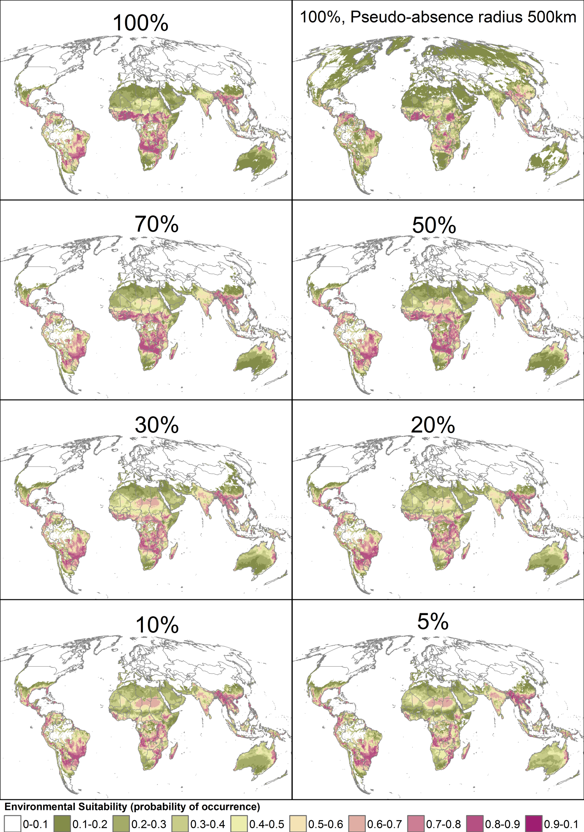
Figure S1. Effect of different sub-sampling proportions and pseudo-absence backgrounds on ensemble SDM projections.
Figure S2. Effect of different sub-sampling proportions and geographic pseudo-absence selection backgrounds on similarity between global ensemble projections. Balanced Accuracy is the proportion of the grid-cells that are predicted to be in the relevant class by one projection that are also predicted to be in that class by the other projection. Each line represents the Balanced Accuracy of two projections across five suitability categories. Colours indicate the difference in the percentage of African distribution data used to build the ensembles (e.g. ‘10’ could represent 10% vs 20%, 20% vs 30%, etc…). Heavier lines indicate comparisons between results from models using 100% of distribution data and the entire geographic background and other models.
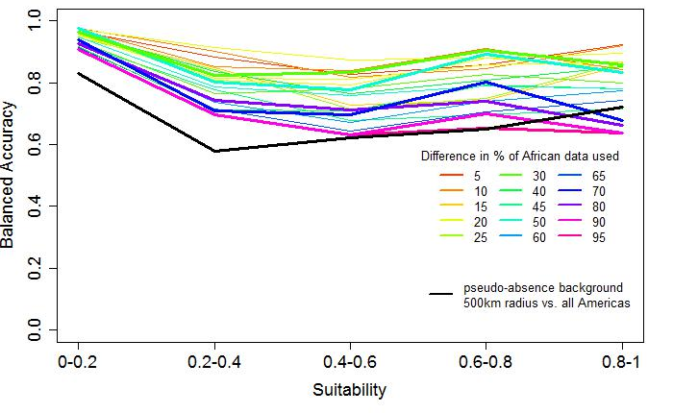

Figure S3. Histograms of environmental variables in 10 arc-minute grid-cells from which fall armyworm is recorded (using all presences recorded from the Americas and Africa).

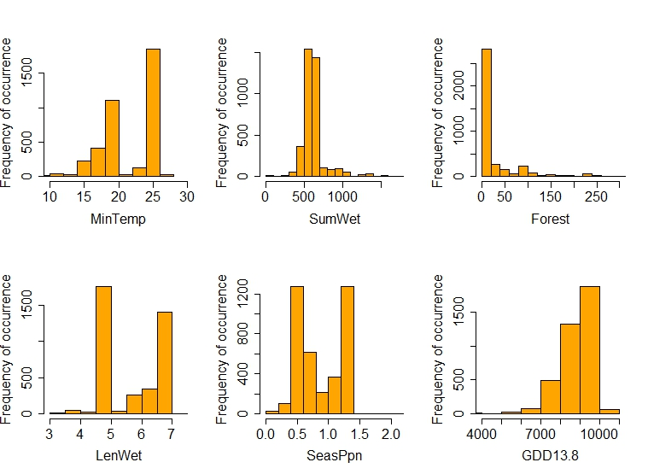
Figure S4.Multivariate Environmental Similarity Surface (MESS) analysis, comparing global environmental conditions to the conditions included in SDMs using 100% of distribution data and the entire geographic pseudo-absence background. Values for each individual environmental variable and the combined MESS analysis are shown. For individual environmental variables values below 0 indicate grid-cells where environment falls outside the range of the data used to construct SDMs. For the combined MESS analysis values below 0.5 indicate grid-cells where environment falls outside the range of the data used to construct SDMs.
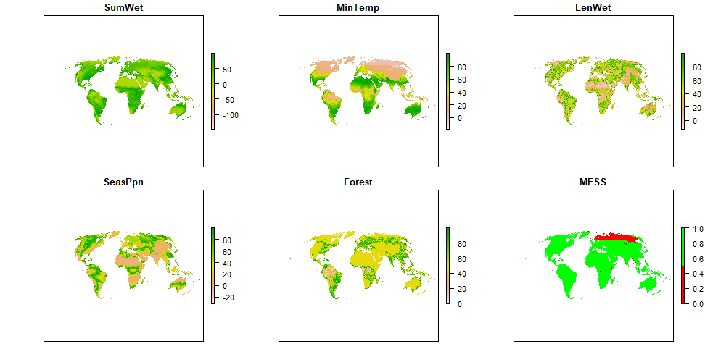

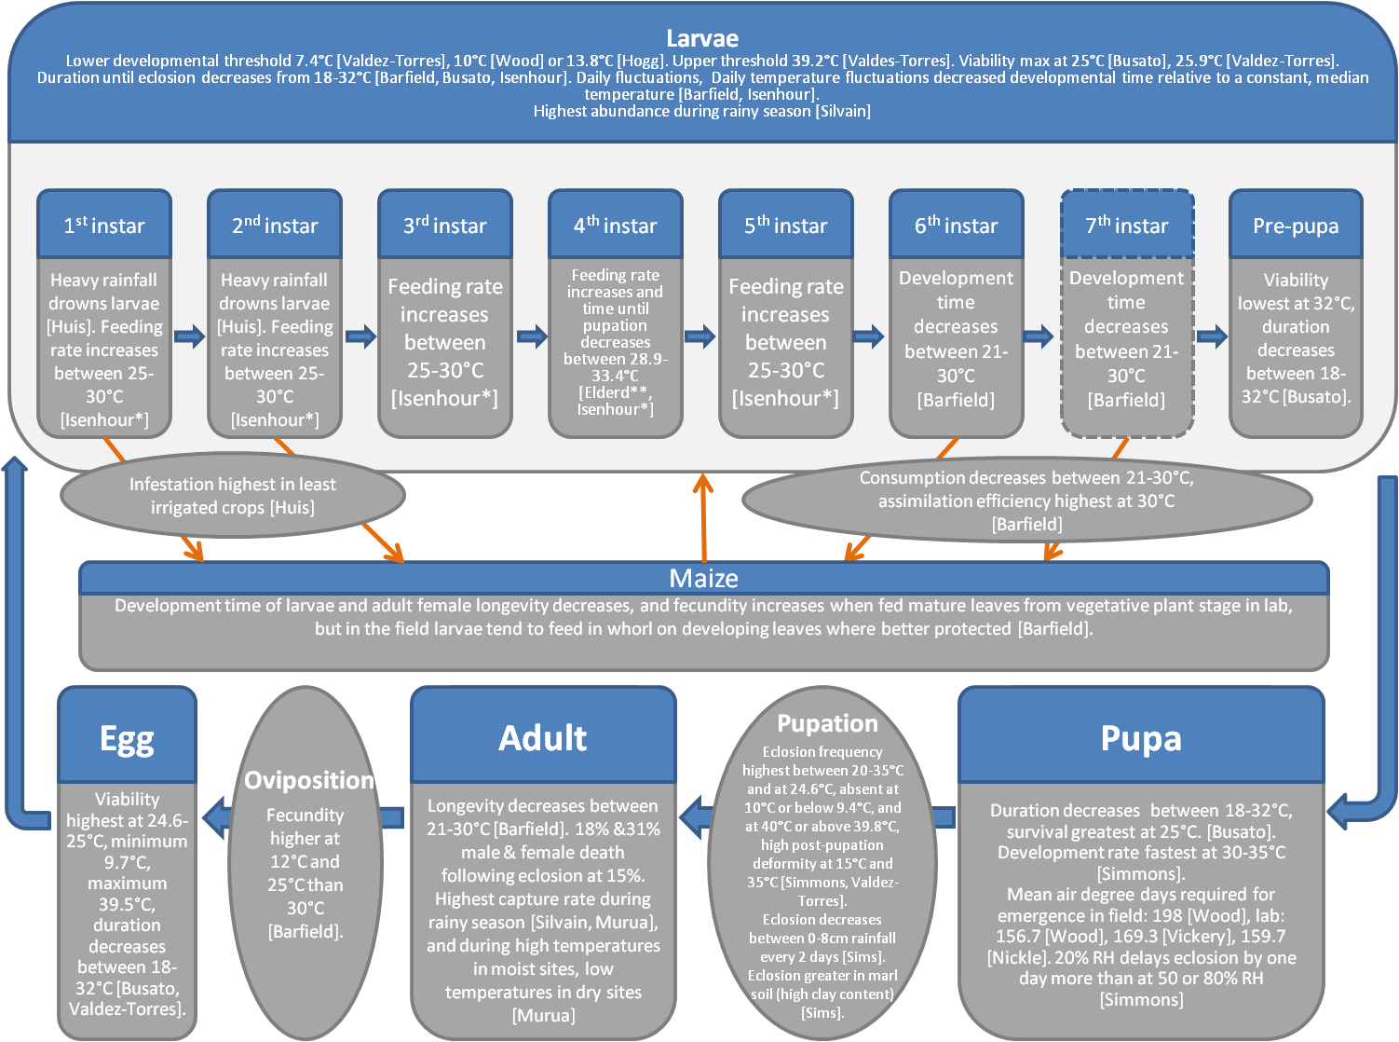
Figure S5. Empirically measured environmental effects on fall armyworm life cycle. Summary of data from literature of temperature, moisture, soil, and host plant effects on fall armyworm survival and developmental time, and observations of abundances in the field under different conditions and seasons. All studies were conducted with populations from the Americas. Rectangles are life stages, ovals are processes. Orange arrows represent effects of fall armyworm on maize or vice versa. The occurrence of a 7th instar is not universally reported. Only direct effects (measured or imputed) of the environment and host on fall armyworm were included. Unless otherwise noted, moths for experiments were reared on fresh maize or an artificial diet. RH is relative humidity. *Feeding rate applies to first nine days of larval stages, which is approximately the first four larval instars. **Feeding rate measured on soy-bean leaf.

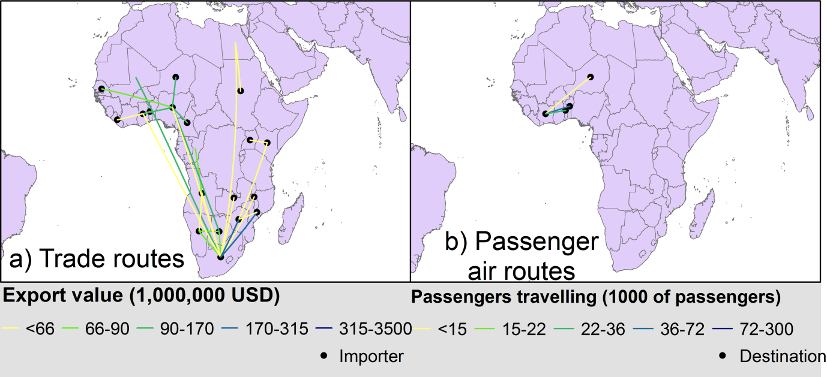

Figure S6. Trade and passenger air transportation within Africa. a) value of all exports from 2012-2016 from source sub-Saharan African countries climate to vulnerable countries in Africa. The relationships that fall within the top 5% of trading relationships between all countries globally are shown, and the five colour categories represent 20% quantiles of export values. b) number of passengers in 2013 travelling from source sub-Saharan African countries with their final destination in vulnerable countries in Africa, for flights that are direct or make one connection. The routes that fall within the top 13% of travel routes between all countries globally are shown, and the five colour categories represent 20% quantiles of passenger numbers. None of the North African countries importing from sub-Saharan Africa fall within the top 5% of trade routes from source to vulnerable countries globally. No North African country has passenger arrivals within the top 13% of passenger air routes from source to vulnerable countries globally.

