Parthenium in Pakistan - Data collection method (‘low resolution data’)

Data collection aims
- To collect ground truthing data over a large spatial area on the abundance of Parthenium across different habitats
- To validate remote sensing models for Parthenium classification using satellite/drone imagery
- To calibrate and validate potential distribution models of Parthenium in Pakistan in relation with landscape and climate characteristics with a fine resolution
- Focus of study is on agricultural areas

Method
Data collection in Pakistan consisted of 4 rounds of fieldwork. Fieldwork was carried out in Dec 2018, March 2019, June 2019 and October 2019 to capture data at different stages of Parthenium development and across different agricultural seasons. A roadside survey protocol was developed in order to collect data across a wide geographic area in a short amount of time. Fieldwork rounds 1&2 focussed on the north of Pakistan in Khyber Pakhtunkhwa and Punjab provinces. In rounds 3&4 the study area was increased to include the Sindh province. A stratified random sampling method was used to select fieldwork locations.

District selection: 10 districts were selected from each province. Districts were classified according to their dominant agroecological zone (AEZ) (IWMI, 2003). A proportionate number of districts were selected at random from each AEZ. In fieldwork rounds 3&4 the study area was increased to include 4 additional districts in Khyber Pakhtunkhwa, 5 additional districts in Punjab and 2 districts in the Sindh province.

Survey grid selection: Each district was divided into 10x10km grid cells. 20 grid cells were selected from each province. In the first round of fieldwork, grid cells were selected at random from each district in proportion to its area. After random selection, each grid square was checked for suitability to the study. With a focus on agricultural areas, a grid cell was randomly re-selected if >80% of its area was classified as “urban” according to the Global Rural-Urban Mapping Project (GRUMP) (CIESIN et al, 2017). In addition, a grid cell was randomly re-selected if >80% of its area was classified as “Bare areas” or “Water bodies” according to GlobCover 2009 Land Cover Map (Arino et al, 2012). To check the accessibility of a grid cell, an assessment was made using OpenStreetMap for the presence of a road network. In the absence of any road network, the cell was replaced by the nearest cell with roads. In subsequent rounds of fieldwork, a randomly selected 50% of grids were revisited, and 50% were new grid cells were randomly selected and checked using the criteria above. The random district and grid cell selection, and subsequent checking was carried out using QGIS Geographical Information System software.

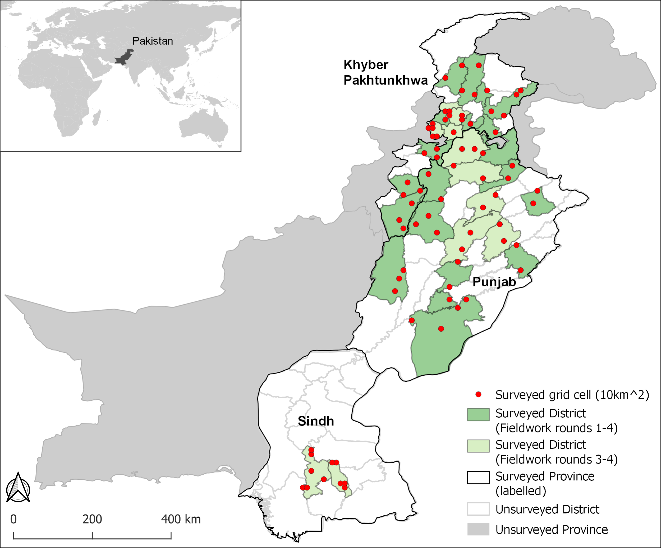
Map showing fieldwork survey locations

Roadside survey site selection: In each 10x10km grid cell a survey was conducted on the left hand side of the road every 2km where it was safe to stop, as measured by the vehicle odometer. Depending on the road network, approx. 20 surveys were completed per cell with the aim to collect data from a range of different road types. Where fewer than 20 surveys were completed, additional survey sites were selected from the nearest accessible grid cell(s). If a survey site was judged to be >80% urban it was skipped.

Roadside survey protocol: At each survey site, data was recorded for an area of 20x20m. WGS84 latitude and longitude coordinates were recorded from the roadside and at 20m away perpendicular to the road. A landscape photograph was taken of each survey site. Details were recorded of the road type, habitat (type, percentage cover), Parthenium (presence/absence, phenological stage, abundance per habitat) crop (type, percentage cover, phenological stage, irrigation type), and presence and impact of any Parthenium natural enemies. Roads were classified based on a subset of OpenStreetMap road classifications and habitats were classified using a Pakistan Land Cover classification. Data was recorded on site using an android tablet and customised data entry forms using the ODK collect app.

Road classification based on OpenStreetMap classes:

1 | Major road | National highway, motorway, expressway. Heavy traffic
2 | Secondary road | Provincial highway, medium sized road. Moderate traffic
3 | Minor road | Smaller road, residential road. Light traffic
4 | Track | Unpaved road, farm track, forest track. Infrequent traffic
5 | Path | No vehicle traffic

Habitat classification:

 | Habitat classification | Description
1 | Orchard | Orchards are the cultivated or maintained areas for the production of fruits, nuts, berries, or ornamentals. Orchards are always found in the agricultural irrigated area. An herbaceous crop could be present beneath the trees.
2 | Field crop - bare soil | Areas used for the production of annual crops. Recently ploughed with no evidence of crop planted and no other vegetation
3 | Field crop - fallow | Areas used for the production of annual crops. No evidence of crop planted but left to weeds
4 | Field crop - planted | Areas used for the production of annual crops. With evidence of crop planted
5 | Field crop- margin | Crop field margin with distinctive vegetation. Usually weeds or other vegetation characteristic of disturbed areas.
6 | Forest | Area characterized by tree cover natural, semi-natural or planted woody vegetation, generally greater than 6 meters tall. Tree cover should be more than 10%. Forest  includes both natural and planted forest. Tree forest plantation refers to governmental plantation. This class can be identified with large area and regular shape. Tree orchard for fruits is included in class “Orchards”
7 | Natural vegetation in wet areas | Vegetation close to water bodies including river banks, wetlands, shrubs/trees in wetland
8 | Shrubland and woodland | Areas characterized by natural or semi-natural woody with aerial stems, generally less than 6 meters tall, with individuals or clumps not touching to interlocking. Shrub (woody less than 6 m) should cover more than 10%.
9 | Grassland | Areas with mandatory presence of herbaceous growth forms  varies from 10 to 100% and optional presence of  trees and shrubs of up to 10% of cover.
10 | Building, roads or runways | built-up areas (urban, industrial, airport etc.) including vegetation in the margins. If this vegetation is managed (.e.g ornamental) it will be class parks/gardens.
11 | Parks, gardens and cemeteries | built-ups with vegetation such as gardens, golf courses, urban recreation parks usually irrigated and with ornamental plants
12 | Bare areas | Areas with sparse vegetation but the percentage coverage should be less than 10%. It can include sand Dunes, bare rocks, and desert flat plain. Not include crop land temporally without vegetation (see class 2)
13 | Lakes, ponds, rivers and streams | Areas which are covered with fresh or saline water such as river, streams, ponds and lakes are grouped in this class.
14 | Agroforestry | Crop and trees (no fruit trees as this will be orchard)

Notes

The southern half of Bahawalpur district in Punjab province doesn’t contain many significant roads and little or no vegetation. Grid cells were randomly selected squares from the northern part of this district.

Some grid cells couldn’t be visited during every round of fieldwork due to; snow cover, poor road quality, restricted access areas for security reasons. Depending on severity, grids were either skipped or survey sites were taken from the nearest accessible grid cell.

References:

Arino, Olivier; Ramos Perez, Jose Julio; Kalogirou, Vasileios; Bontemps, Sophie; Defourny, Pierre; Van Bogaert, Eric (2012): Global Land Cover Map for 2009 (GlobCover 2009). © European Space Agency (ESA) & Université catholique de Louvain (UCL), PANGAEA, https://doi.org/10.1594/PANGAEA.787668. Accessed 04/05/2018

Center for International Earth Science Information Network - CIESIN - Columbia University, CUNY Institute for Demographic Research - CIDR, International Food Policy Research Institute - IFPRI, The World Bank, and Centro Internacional de Agricultura Tropical - CIAT. 2017. Global Rural-Urban Mapping Project, Version 1 (GRUMPv1): Urban Extent Polygons, Revision 01. Palisades, NY: NASA Socioeconomic Data and Applications Center (SEDAC). https://doi.org/10.7927/H4Z31WKF. Accessed 04/05/2018.

International Water Management Institute (IWMI) (2003) [shapefile] Agro-ecological zones of Pakistan. Pakistan. http://173.255.241.220/layers/133 Accessed 14/11/2018.

